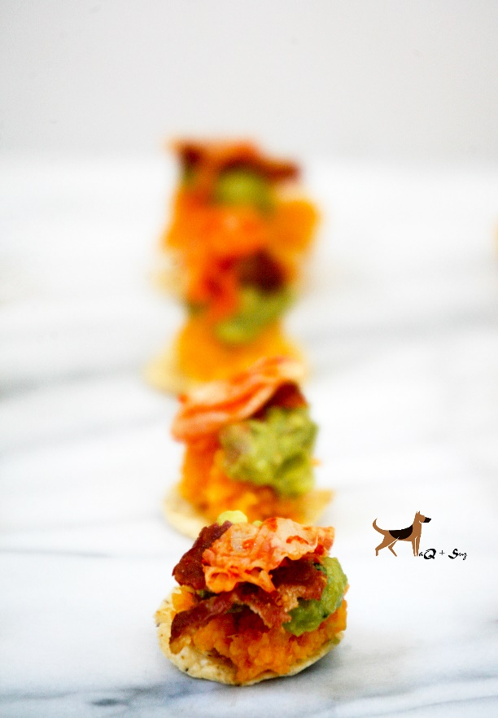

Gameday Kimchi Sweet Potato Guacamole Bites with Bacon

Serves 4-6

Ingredients:

2 large Sweet Potato, cooked, unpeeled and mashed
4 slices Bacon, cooked
4-5 GOODFOODS Grab N' Go Chunky Guacamole
1/4c. Kimchi, chopped
1/4c. chicken broth
salt & pepper, evoo

Directions:

1. Clean sweet potatoes leaving skin on. Place in a large pot and cover with water. Boil potatoes for about 20 minutes until tender.
2. Remove potatoes from water and cool. Peel and smash with fork. Mix in chicken broth, evoo, and s&p.
3. Plate tortilla chips down on serving plate. Use a dollop of mashed sweet potato on each chip, followed by GOODFOODS Chunky Guacamole, bacon and kimchi.
4. Serve immediately or refrigerate for later.

