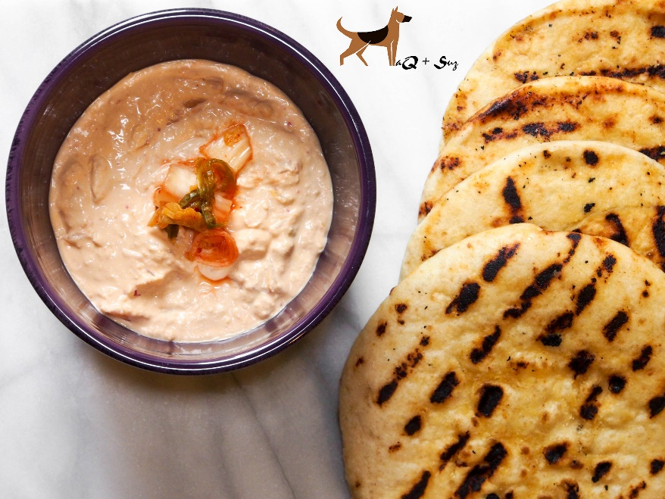
Kimchi Hummus
Serves 4-6
Ingredients:
16 ounces can chickpeas
¼ cups kimchi (napa cabbage chopped)
¼ cup tahini sauce
4 tablespoons fresh lemon juice
¼ cup water
Directions:
- Add all the ingredients except kimchi a blender. Blend the ingredients on high until smooth. Add in chopped kimchi with juice, omit the juice if you want the hummus to have a thicker base.

