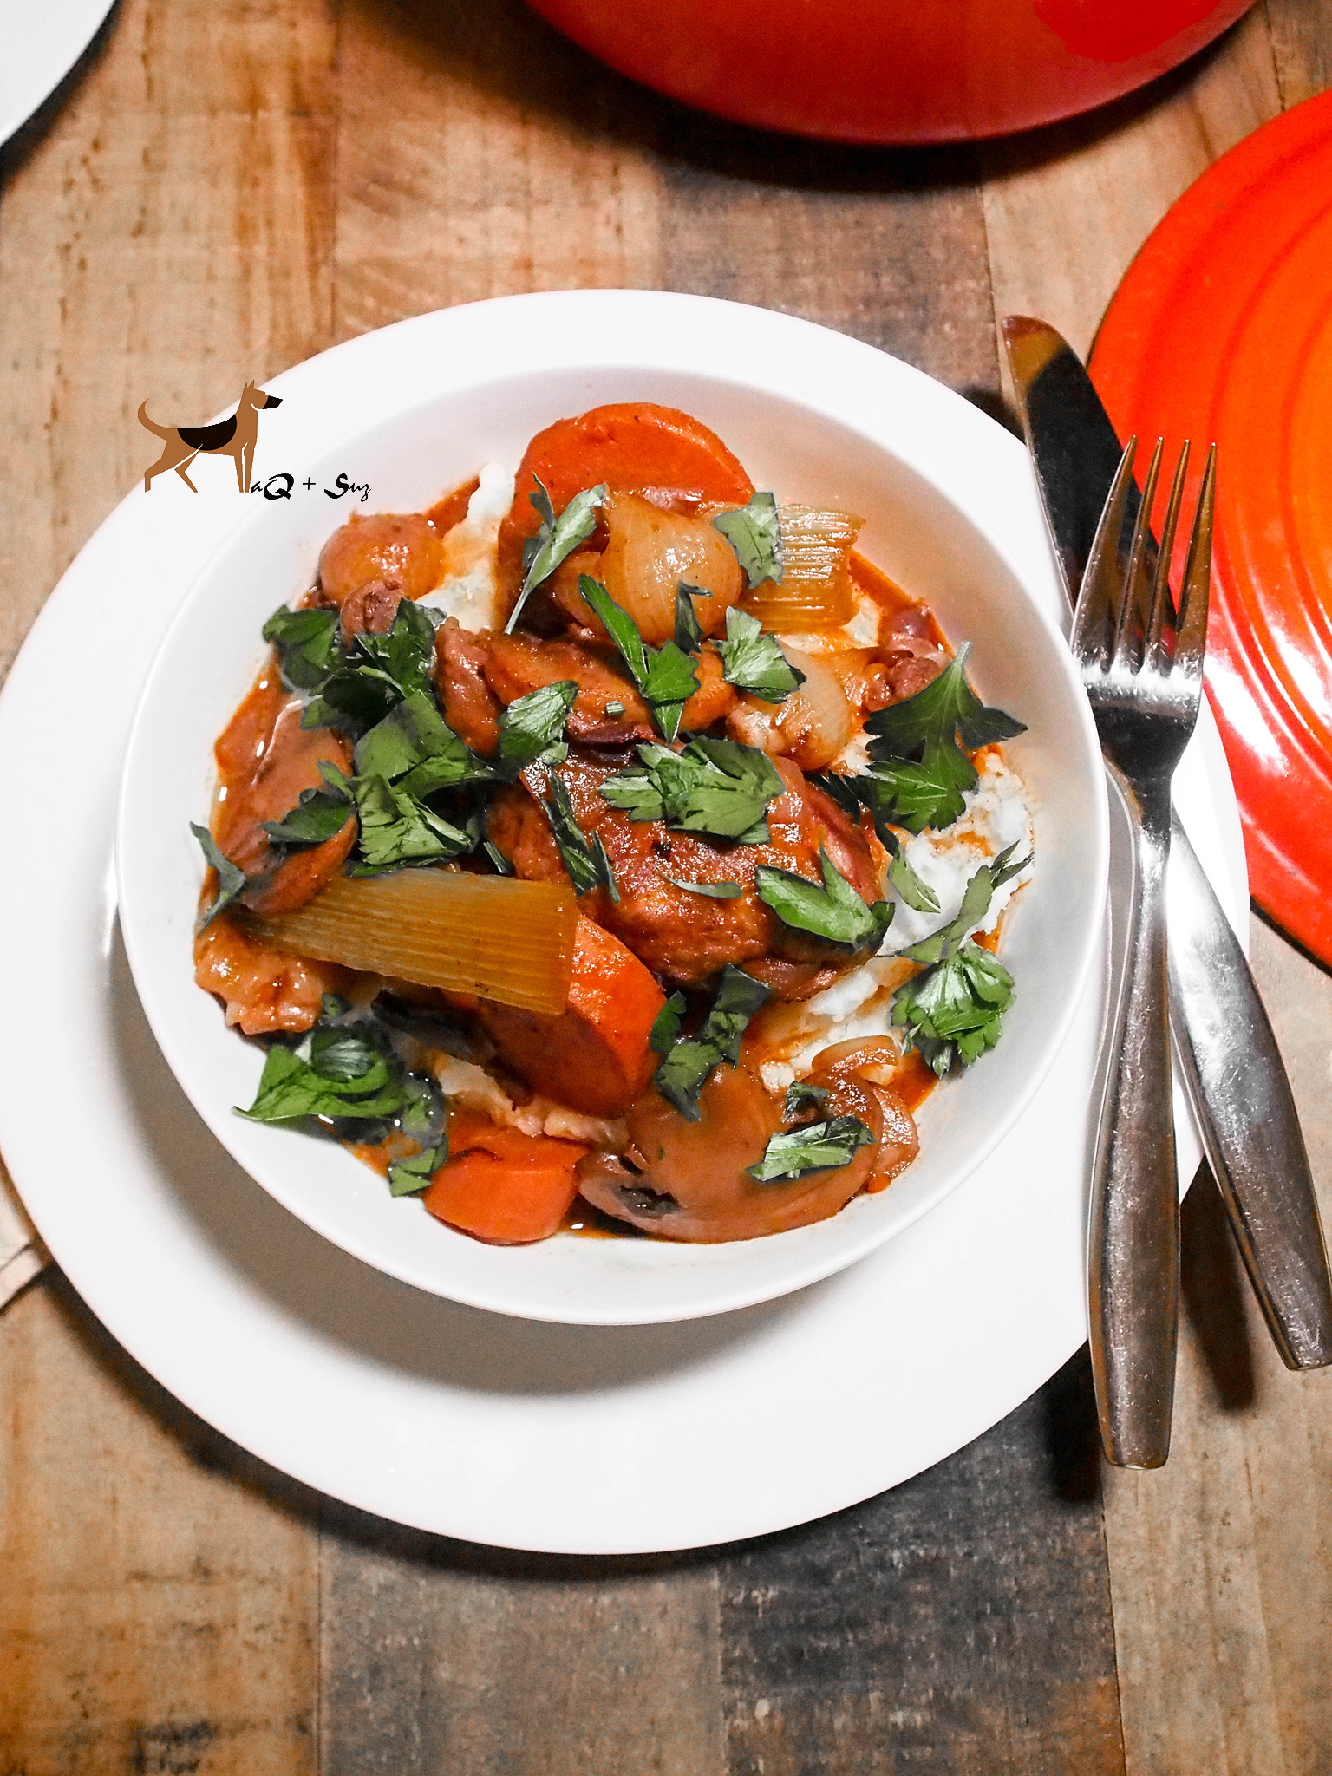
Korean Coq Au Vin
Serves 2-4
Ingredients:
24 to 30 pearl onions 4 chicken thighs and legs, or 1 (5 to 7-pound) stewing chicken ¼ to ½ c AP flour 2 Tbsp water 6 ounces bacon, chopped 8 ounces button mushrooms, sliced 1 Tbsp butter 2 bottles red wine, preferably pinot noir or cabernet 2 Tbsp Gochujang 2 Tbsp tomato paste 1 medium onion, chopped 2 stalks celery, quartered 2 medium carrots, quartered 3 cloves garlic, crushed 6 to 8 sprigs fresh thyme 1 bay leaf 2 cups chicken stock
Directions:
Preheat oven to 245 degrees F.
Cut off the root end of each pearl onion and make an "x" with your knife in its place. Bring a pot of water to a boil and drop in the onions for 1 minute. Remove the onions. Allow them to cool, and then peel. You should be able to slide the onions right out of their skin. Set aside.
Sprinkle the chicken on all sides with salt and freshly ground black pepper. Place the chicken pieces, a few at a time, into a large sealable plastic bag along with the flour. Shake to coat all of the pieces of the chicken. Remove the chicken from the bag to a metal rack.
Add the 2 tablespoons of water to a large, 12-inch sauté pan over medium heat along with the bacon. Cover and cook until the water is gone, and then continue to cook until the bacon are golden brown and crispy, approximately 8 to 10 minutes. Remove the salt pork from the pan and set aside.
In the same pan, using the remaining fat, add the pearl onions, sprinkle with salt and pepper, and sauté until lightly brown, approximately 8 to 10 minutes. Remove the onions from the pan and set aside. Next, brown the chicken pieces on each side until golden brown, working in batches if necessary to not overcrowd the pan. Transfer the chicken into a 7 to 8-quart enameled cast iron Dutch oven.
Add the mushrooms to the same 12-inch sauté pan, adding the 1-tablespoon of butter if needed, and sauté until they give up their liquid, approximately 5 minutes. Remove and set aside.
Pour off any remaining fat and deglaze the pan with approximately 1 cup of the wine. Pour this into the Dutch oven along with the chicken stock, tomato paste, gochujang, quartered onion, carrots, celery, garlic, thyme, and bay leaf. Add all of the remaining wine.
Place the chicken in the oven and cook for 2 to 2 1/2 hours, or until the chicken is tender. Maintain a very gentle simmer and stir occasionally.
Once the chicken is done, remove it to a heatproof container, cover, and place it in the oven to keep warm. Strain the sauce in a colander and remove the carrots, onion, celery, thyme, garlic, and bay leaf. Return the sauce to the pot, place over medium heat, and reduce by 1/3. Depending on how much liquid you actually began with, this should take 20 to 45 minutes.
Once the sauce has thickened, add the pearl onions, mushrooms, and bacon and cook for another 15 minutes or until the heated through. Taste and adjust seasoning if necessary, remove from the heat, add the chicken and serve.

*Tips: If you want to do it overnight, just do everything up to putting the chicken in the oven. That part is for the next day The longer you marinate, the better the flavor! xo

