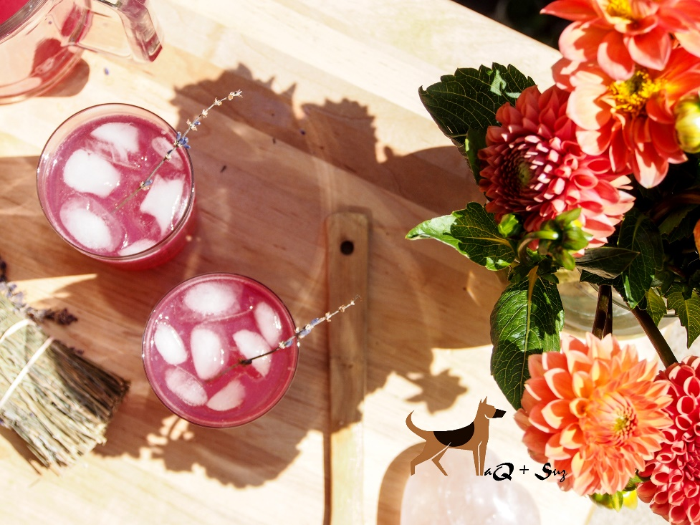
Lavender Soju Lemonade

Serves 8

Ingredients:

1c. lavender flowers
2c. boiling water
2c. cold water
1c. lemon juice
1c. sugar
5fl. oz. soju
1 tray ice cubes

Directions:

Place freshly cut lavender flowers in a pitcher; pour the boiling water over lavender; cover with plastic wrap and allow to steep 10 minutes; strain and discard the lavender from the water and return the water to the pitcher. Add cold water, lemon juice, and sugar to the pitcher and stir until the sugar dissolves. Add in soju, mix well. Refrigerate until ready to serve. Garnish with a stem of lavender. Enjoy!

