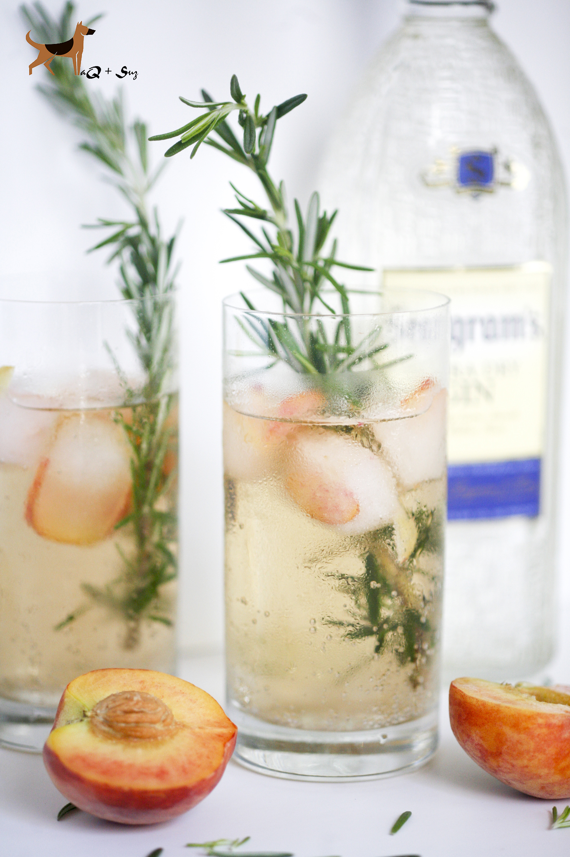
Rosemary Peach Gin Cocktail

Serves 2

Ingredients:

2 Peach

4 Rosemary Sprigs

2 Tbsp Freshly-Squeezed Lemon Juice

1 20 oz. Ginger Ale

4 Tbsp. Rosemary Simple Syrup (1/2 Cup of Sugar, 1/2 Cup of Water, bring to a boil, remove from heat, add rosemary sprigs, stir, and let cool. Chill until ready to use.)

3 oz. Seagram's Extra Dry Gin

Directions:

1. Thinly slice half of peach. Make ice cubes with them by first adding the slice in each cube before adding water.
2. In a cocktail shaker, add ice, rosemary syrup, lemon juice, ginger ale and Seagram's extra dry gin. Shake well.
3. Pour over crushed ice evenly between two glasses.
4. Garnish with extra peach slices (optional) and rosemary sprigs. Serve immediately

