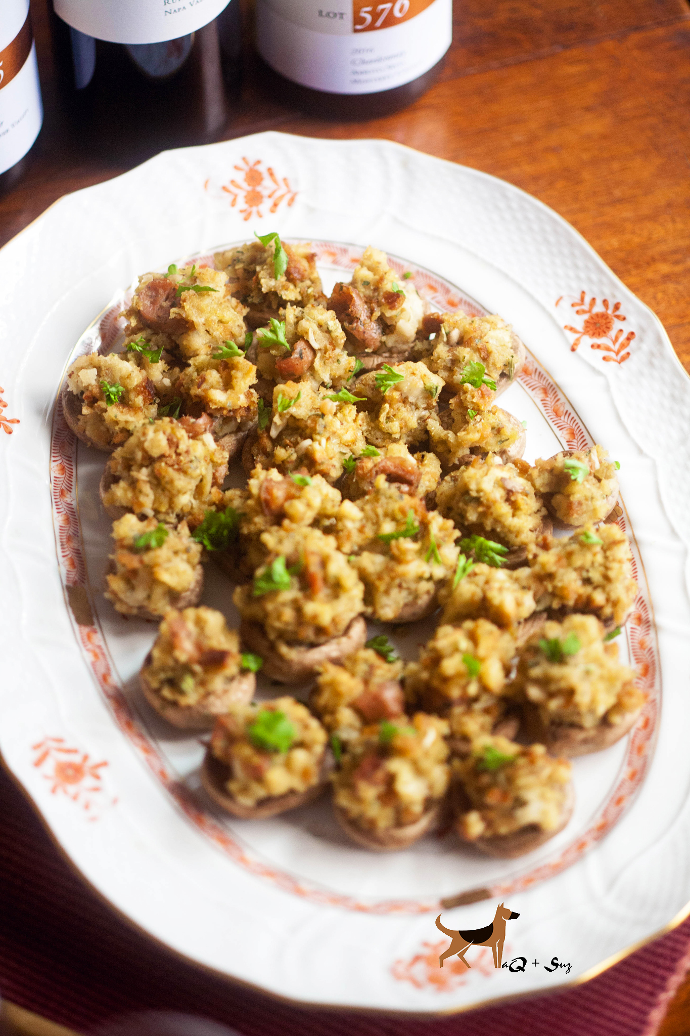
Stuffed Mushrooms
Serves 2-4

Ingredients:

24 oz fresh whole white mushrooms (about 28)
1/2 lb bulk spicy Italian sausage, cooked and drained
1 box Stove Top 'Savory Herbs' stuffing

Directions:
Heat oven to 375°F. Remove stems from mushroom caps; discard stems.
On an ungreased 15x10-inch pan with sides, place mushrooms, stem-side down. Bake 10 to 12 minutes or until they just start to release their juices. Remove mushrooms from pan; drain. Remove any liquid from pan.

In a medium bowl, mix Stove Top (cooked) and sausage until well blended. Divide and spoon filling into mushroom caps, mounding slightly. Place mushrooms in the same 15x10-inch pan.

Bake 13 to 18 minutes or until golden brown on top and heated through.

