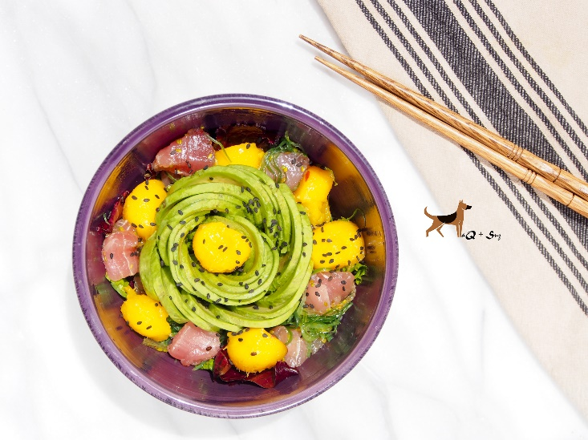
Tuna Poke Bowl with Avocado Rose

Serves 1 Salad

Ingredients:
2 tablespoons vegetable oil
1 tablespoon ponzu sauce
1 tablespoon sesame oil
4 ounces sushi grade tuna, diced in large chunks
½ mango, diced in large chunks or made into mango balls
½ cup store-bought seaweed salad
2 cups loosely packed spring lettuce mix
1 avocado, sliced & rolled into a rose
A sprinkle of black sesame seeds

Directions:
- In a small bowl, whisk the vegetable oil, ponzu sauce and sesame oil until well blended.
- Add the tuna, mango and seaweed salad to a bowl and drizzle with 1 tablespoon or so of the dressing. Sprinkle with the sesame seeds and stir to coat.
- In a different bowl, coat the spring lettuce mix with the rest of the dressing. Top with the tuna mixture. Create an avocado rose and place in center. Sprinkle with sesame seeds. Serve immediately.

