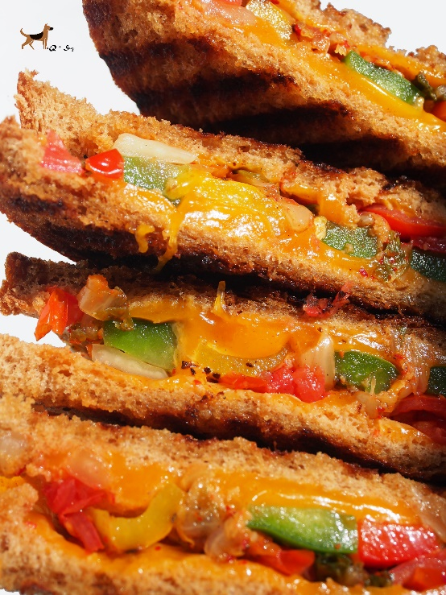

Veggie-Packed Kimchi Grilled Cheese Sandwich

Serves 2

Ingredients:

4 slices whole wheat bread
3 Tbsp butter
4 slices Colby Jack cheese
1/2 cup kimchi
Few slices green, red & yellow pepper
5-6 cherry tomatoes

Directions:

1. Melt one third of butter in a large non-stick skillet (or grill pan in my case) over medium heat until foaming subsides. Add 2 slices of bread, then 2 slices of cheese on top, press firmly into pan and cook until golden brown on bottom side (approx 2 min.)
2. Char kimchi, peppers & cherry tomatoes while the bread is grilling for approx. 4-5minutes.
3. Chop up kimchi and veggies, then add on top of cheese. Remove sandwich using a flexible metal spatula. Add the remaining butter. Repeat steps 1-3 with second sandwich. Serve & enjoy immediately. :)

