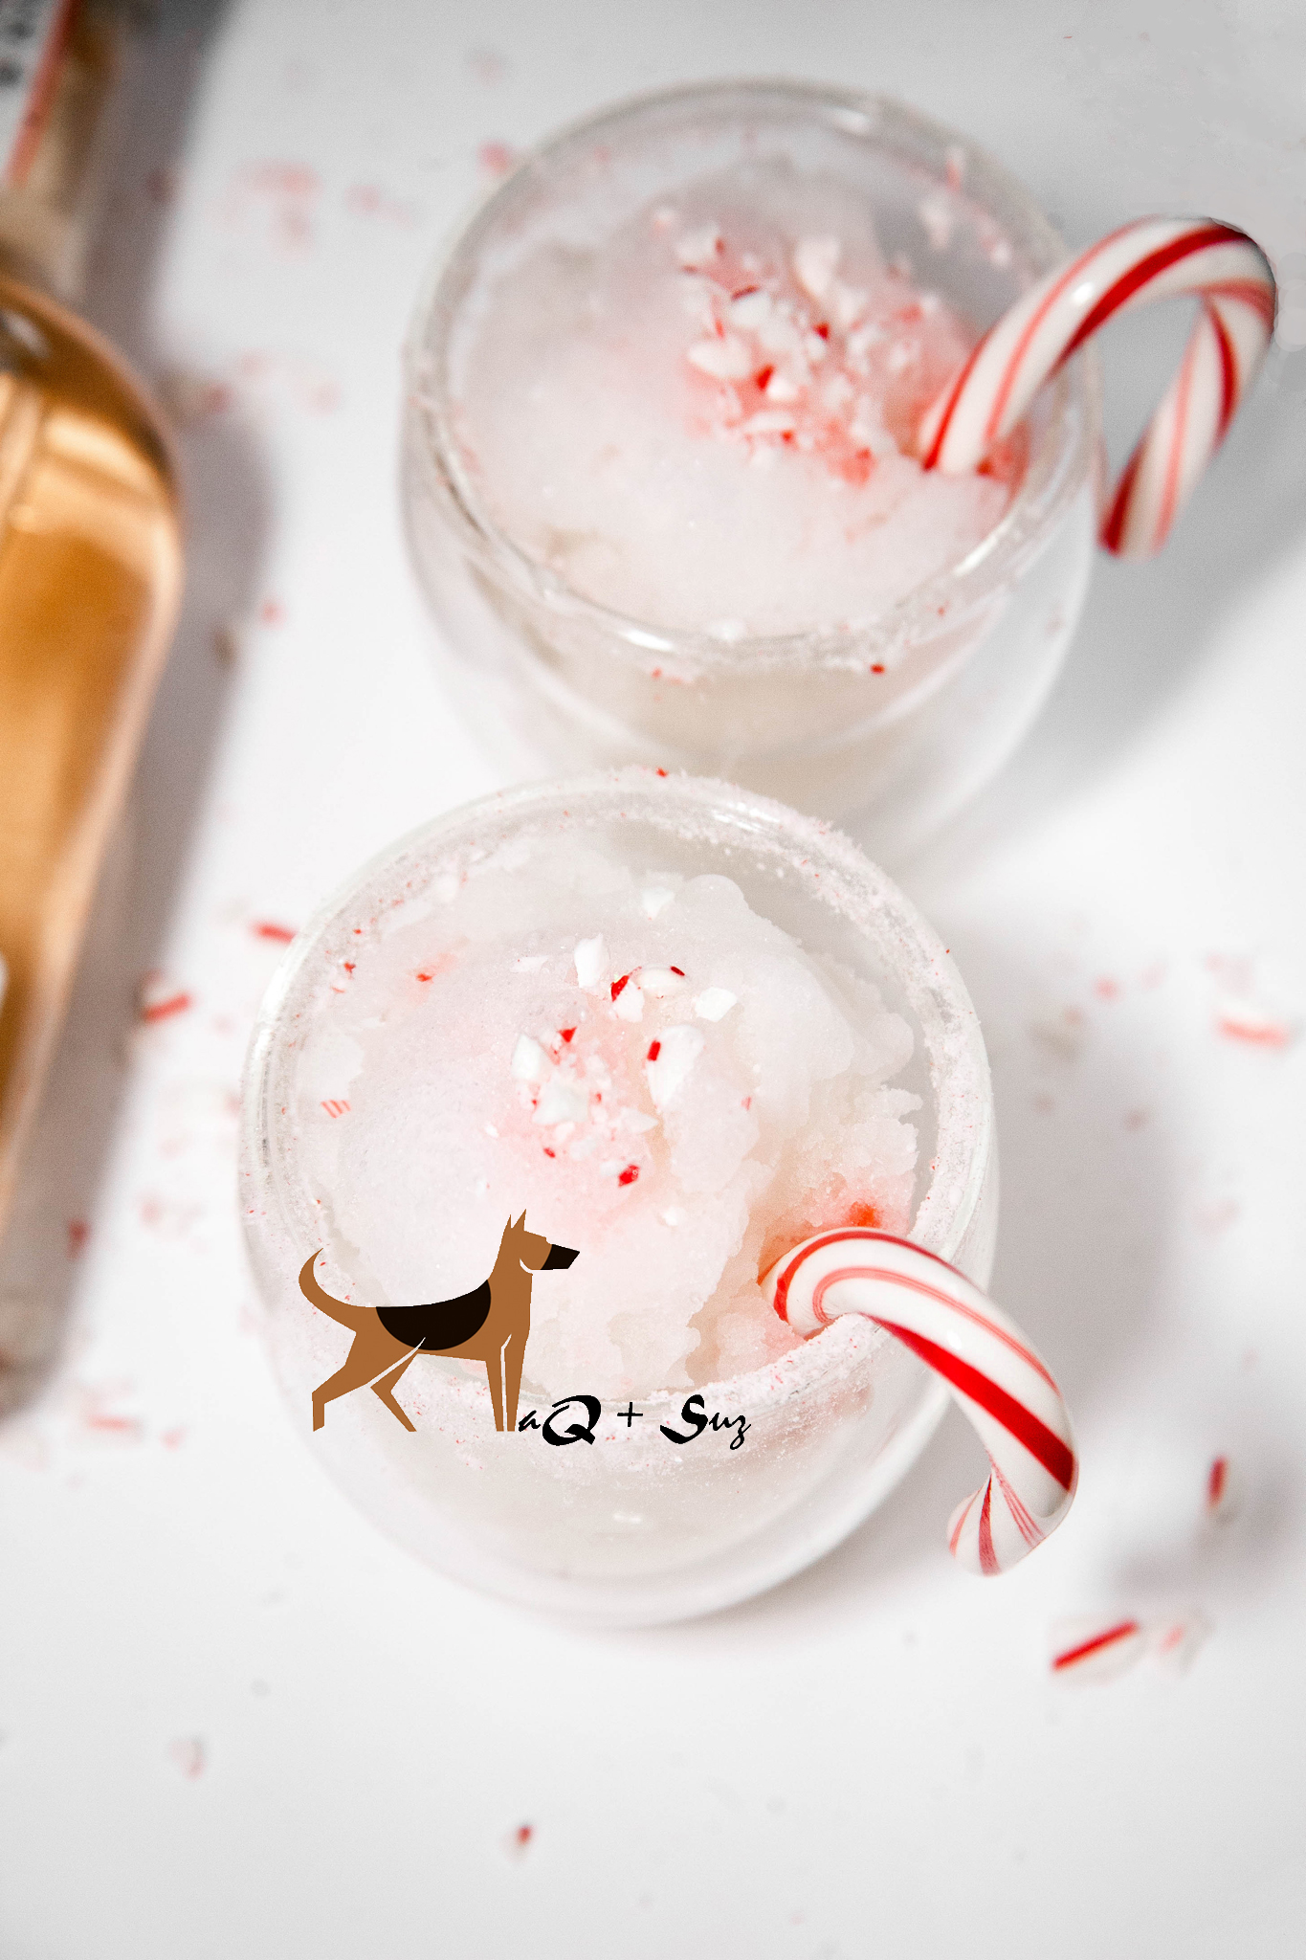

White Christmas Margarita Recipe

Serves 2-4

Ingredients:

14oz coconut milk
12 oz Código 1530 Rosa Tequila
1/2 c lime juice
8oz peppermint schnapps
2c ice

Directions:

1.Crush hard peppermint candy or candy canes to rim to glasses.

2. In a blender, mix all ingredients until left with a smooth frozen brew. Garnish with candy canes.

