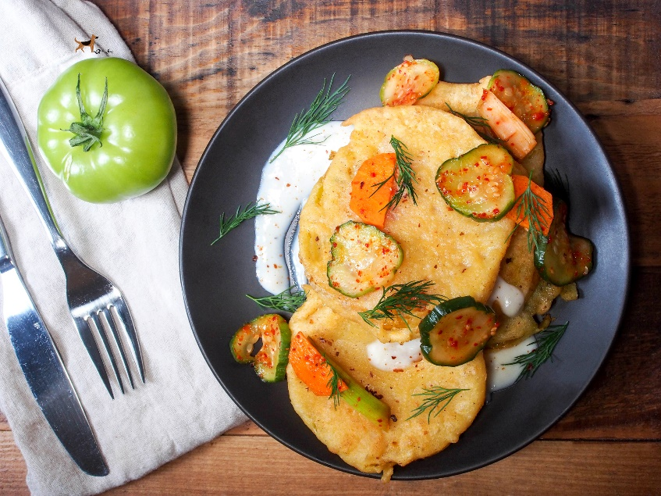
Fried Green Tomatoes
with cucumber carrot kimchi, dill & buttermilk sauce
Serves 2-4
Ingredients:
1 medium green tomatoes (per person)
Batter:
3/4 c all-purpose flour
1/4 c yellow cornmeal
3/4 c buttermilk
salt & pepper
enough bacon drippings to fill 2" deep in a skillet /pan
Sauce:
2 TB coconut oil
1/4 c all-purpose flour
1 1/2 c milk
1/2 c buttermilk
1 TB ranch dressing
salt & pepper
Directions:
Slice tomatoes about 1/4 inch thick, season with salt and pepper and set aside. Combine batter then coat tomatoes on both sides. In a large skillet, heat enough bacon drippings to coat the bottom of the pan and fry tomatoes until lightly browned on both sides. (2-3 min per side) If oil sizzles or pops before you put the tomatoes in, it's too hot! Transfer to a colander or wire cooling rack to drain. To keep the tomatoes from getting soggy before they're served, the best way is to stand them up like wheels in a serving dish instead of stacking them. To make the sauce, add coconut oil in a saucepan until melted over medium heat. Whisk in flour, then milk & buttermilk until mixture is thickened and bubbly. Garnish with fresh dill, cucumber carrot kimchi & red pepper flakes. Serve immediately and enjoy! (You'll think you died and gone to heaven!)

