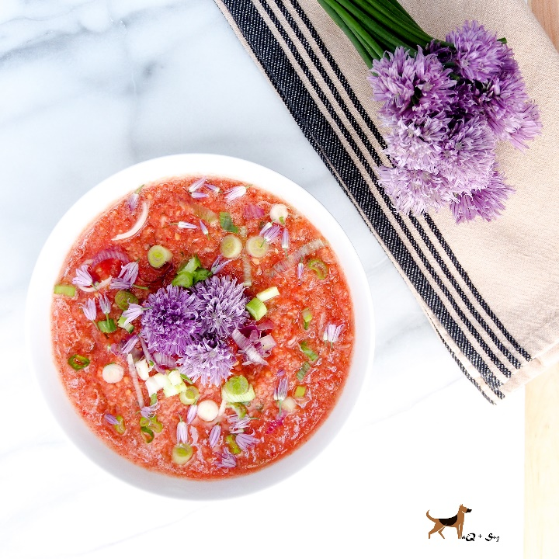
Kimchi Gazpacho
Serves 2-3
Ingredients:
3 c chopped tomatoes (peeled and seeded)
1/2 c kimchi with juice (chopped)
1/2 c Kirby cucumber (peeled and chopped)
1 large garlic clove, chopped
3 Tbs. rice wine
Salt & pepper to taste
Chive blossoms & red scallions, for garnish, optional
Directions:
In a blender, puree tomatoes, kimchi, cucumber, and garlic. Add rice wine, salt, and pepper. Taste for accurate seasonings. Chill. Pour into bowl(s), garnish, and serve immediately.

