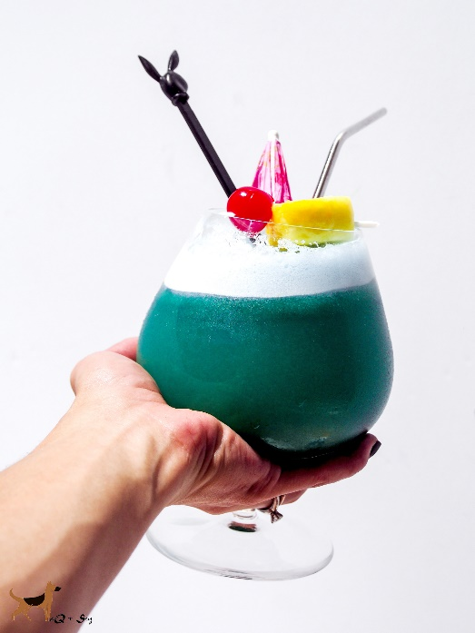

Korean Hawaiian Blue
Serves 2
Ingredients:
1.5 oz. Korean Soju
2 oz Blue Curacao
6 fresh pineapple juice
.5 oz. melted coconut oil
Fresh pineapple chunk and Maraschino cherry for garnish
Directions:
Shake all together with ice and strain into a Daiquiri glass filled with ice. Garnish with pineapple and cherry. Feel free to add an umbrella for tropical vibes. Enjoy! :)

