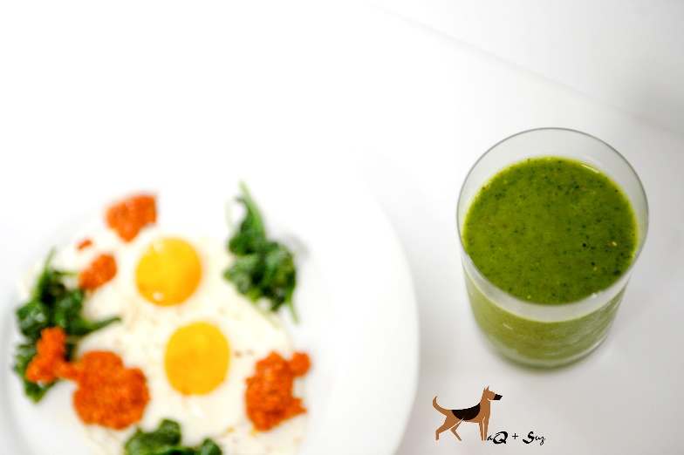

Sun Basket Two Breakfasts

Serves 2
Fried Eggs with Spinach and Romesco

Ingredients:
4 pasture-raised organic eggs
2 ounces baby spinach
Romesco
(roasted red peppers - almonds - fresh garlic - sherry vinegar - olive oil - salt - sweet smoked paprika)
1 tbsp butter
salt & pepper
Directions:
1. In a medium frying pan, heat butter until hot but not smoking. Crack the eggs directly into the pan and season with salt and pepper. Cook until the whites have set and the yolks are slightly runny, 2 to 3 minutes. If you prefer firmer yolks, cook 1 to 2 minutes longer. Transfer to a plate.

2. Add the spinach to the pan, season with salt, and cook just until wilted, 1 to 2 minutes.

3. Transfer the spinach and eggs to individual plates and spoon the romesco on top. Season to taste with salt and pepper and serve.

Mango-Matcha Smoothie

Serves 2

Ingredients:
Fresh ginger
1 cup coconut milk
1 tablespoon maple syrup
2 cups mango pieces
1 ounce baby spinach
1 tbsp black chia seeds
2 tsp matcha powder

Directions:
1. In a blender, combine coconut milk and maple syrup with the ginger, mango, spinach, black chia seeds, and matcha. Add 1 cup of ice. Season lightly with salt. Blend until smooth

2. Pour into glasses and serve.

