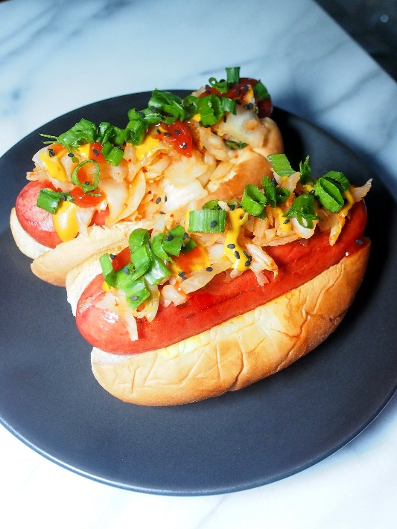
The KimKraut Dog
Serves 2
Ingredients:
4 bratwurst sausages, grilled
4 hot dog buns, toasted
4 tsp mustard
2 tsp soy sauce
1 tsp sugar
1 tsp white vinegar
1/4 tsp salt
4 tsp ketchup
1 tsp sriracha sauce
1/2 cup chopped kimchi (cabbage)
1/2 cup chopped sauerkraut
2 tsp rice vinegar
2 tsp honey
2 green onion, chopped
black sesame seeds, for garnish
Directions:
1. Mix mustard, soy sauce, sugar, white vinegar and salt in a small bowl. Set aside.
2. Mix ketchup and sriracha sauce in another small bowl. Set aside.
3. Combine kimchi, sauerkraut, rice vinegar, and honey in a small bowl to create KimKraut. Set aside.
4. Grill bratwursts. Toast buns at 350°F for 5-7 minutes.
5. Prepare hot dog with sausage, KimKraut, mustard and ketchup sauces, chopped green onion and black sesame seeds.
6. Enjoy!

